Traffic Accident

**PROBLEM:**

The Traffic accidents are occurred in many reasons and many of the persons lost their life. To know which is the main reason for the major accidents and to neglect those accidents.

**ASSUMPTION:**

Let assume that the accidents are made due to the weather of the place And considering the states to get a idea about which states has major number of accidents

By the above assumption, we need to compare the different segments of accidents in the given attributes

library(dplyr)

##   
## Attaching package: 'dplyr'

## The following objects are masked from 'package:stats':  
##   
## filter, lag

## The following objects are masked from 'package:base':  
##   
## intersect, setdiff, setequal, union

library(lattice)  
library(readr)  
library(ggplot2)  
  
data <- read_csv("data.csv")

## Rows: 36 Columns: 16

## ── Column specification ────────────────────────────────────────────────────────  
## Delimiter: ","  
## chr (1): States  
## dbl (15): Sunny_TotalAccidents, Sunny_PersonsKilled, Sunny_PersonsGInjured, ...  
##   
## ℹ Use `spec()` to retrieve the full column specification for this data.  
## ℹ Specify the column types or set `show_col_types = FALSE` to quiet this message.

summary(data)

## States Sunny_TotalAccidents Sunny_PersonsKilled  
## Length:36 Min. : 1.0 Min. : 0.0   
## Class :character 1st Qu.: 269.8 1st Qu.: 88.5   
## Mode :character Median : 3273.5 Median : 1285.5   
## Mean : 9174.9 Mean : 2882.4   
## 3rd Qu.:15595.5 3rd Qu.: 4087.8   
## Max. :48302.0 Max. :12311.0   
## Sunny_PersonsGInjured Sunny_PersonsMInjured2 Sunny_TInjured   
## Min. : 1 Min. : 0.0 Min. : 1.0   
## 1st Qu.: 80 1st Qu.: 106.5 1st Qu.: 250.2   
## Median : 1286 Median : 717.5 Median : 2751.0   
## Mean : 3672 Mean : 5762.6 Mean : 9434.3   
## 3rd Qu.: 3672 3rd Qu.: 6103.5 3rd Qu.:12395.0   
## Max. :28068 Max. :54082.0 Max. :57152.0   
## Rainy_TotalAccidents Rainy_PersonsKilled Rainy_GreviouslyInjured  
## Min. : 0.00 Min. : 0.0 Min. : 0.00   
## 1st Qu.: 48.75 1st Qu.: 13.5 1st Qu.: 18.75   
## Median : 318.50 Median : 110.5 Median : 90.00   
## Mean :1106.25 Mean : 394.1 Mean : 539.78   
## 3rd Qu.:1540.00 3rd Qu.: 651.5 3rd Qu.: 623.50   
## Max. :7001.00 Max. :3781.0 Max. :3513.00   
## Rainy_MinorInjury Rainy_TotalInjured Foggy_TotalAccidents Foggy_PersonsKilled  
## Min. : 0.0 Min. : 0.0 Min. : 0.00 Min. : 0.00   
## 1st Qu.: 27.0 1st Qu.: 57.5 1st Qu.: 18.25 1st Qu.: 5.75   
## Median : 112.0 Median : 338.0 Median : 246.50 Median : 104.50   
## Mean : 559.5 Mean :1099.2 Mean : 933.39 Mean : 372.36   
## 3rd Qu.: 608.5 3rd Qu.:1405.0 3rd Qu.:1058.00 3rd Qu.: 404.00   
## Max. :4794.0 Max. :5920.0 Max. :8031.00 Max. :4177.00   
## Foggy_GreviouslyInjured Foggy_MinorInjury Foggy_TotalInjured  
## Min. : 0.00 Min. : 0.00 Min. : 0.0   
## 1st Qu.: 10.75 1st Qu.: 8.75 1st Qu.: 28.0   
## Median : 98.00 Median : 83.00 Median : 249.5   
## Mean : 413.53 Mean : 441.36 Mean : 854.9   
## 3rd Qu.: 519.75 3rd Qu.: 463.25 3rd Qu.:1114.5   
## Max. :3425.00 Max. :4599.00 Max. :6037.0

is.na(data)

## States Sunny_TotalAccidents Sunny_PersonsKilled Sunny_PersonsGInjured  
## [1,] FALSE FALSE FALSE FALSE  
## [2,] FALSE FALSE FALSE FALSE  
## [3,] FALSE FALSE FALSE FALSE  
## [4,] FALSE FALSE FALSE FALSE  
## [5,] FALSE FALSE FALSE FALSE  
## [6,] FALSE FALSE FALSE FALSE  
## [7,] FALSE FALSE FALSE FALSE  
## [8,] FALSE FALSE FALSE FALSE  
## [9,] FALSE FALSE FALSE FALSE  
## [10,] FALSE FALSE FALSE FALSE  
## [11,] FALSE FALSE FALSE FALSE  
## [12,] FALSE FALSE FALSE FALSE  
## [13,] FALSE FALSE FALSE FALSE  
## [14,] FALSE FALSE FALSE FALSE  
## [15,] FALSE FALSE FALSE FALSE  
## [16,] FALSE FALSE FALSE FALSE  
## [17,] FALSE FALSE FALSE FALSE  
## [18,] FALSE FALSE FALSE FALSE  
## [19,] FALSE FALSE FALSE FALSE  
## [20,] FALSE FALSE FALSE FALSE  
## [21,] FALSE FALSE FALSE FALSE  
## [22,] FALSE FALSE FALSE FALSE  
## [23,] FALSE FALSE FALSE FALSE  
## [24,] FALSE FALSE FALSE FALSE  
## [25,] FALSE FALSE FALSE FALSE  
## [26,] FALSE FALSE FALSE FALSE  
## [27,] FALSE FALSE FALSE FALSE  
## [28,] FALSE FALSE FALSE FALSE  
## [29,] FALSE FALSE FALSE FALSE  
## [30,] FALSE FALSE FALSE FALSE  
## [31,] FALSE FALSE FALSE FALSE  
## [32,] FALSE FALSE FALSE FALSE  
## [33,] FALSE FALSE FALSE FALSE  
## [34,] FALSE FALSE FALSE FALSE  
## [35,] FALSE FALSE FALSE FALSE  
## [36,] FALSE FALSE FALSE FALSE  
## Sunny_PersonsMInjured2 Sunny_TInjured Rainy_TotalAccidents  
## [1,] FALSE FALSE FALSE  
## [2,] FALSE FALSE FALSE  
## [3,] FALSE FALSE FALSE  
## [4,] FALSE FALSE FALSE  
## [5,] FALSE FALSE FALSE  
## [6,] FALSE FALSE FALSE  
## [7,] FALSE FALSE FALSE  
## [8,] FALSE FALSE FALSE  
## [9,] FALSE FALSE FALSE  
## [10,] FALSE FALSE FALSE  
## [11,] FALSE FALSE FALSE  
## [12,] FALSE FALSE FALSE  
## [13,] FALSE FALSE FALSE  
## [14,] FALSE FALSE FALSE  
## [15,] FALSE FALSE FALSE  
## [16,] FALSE FALSE FALSE  
## [17,] FALSE FALSE FALSE  
## [18,] FALSE FALSE FALSE  
## [19,] FALSE FALSE FALSE  
## [20,] FALSE FALSE FALSE  
## [21,] FALSE FALSE FALSE  
## [22,] FALSE FALSE FALSE  
## [23,] FALSE FALSE FALSE  
## [24,] FALSE FALSE FALSE  
## [25,] FALSE FALSE FALSE  
## [26,] FALSE FALSE FALSE  
## [27,] FALSE FALSE FALSE  
## [28,] FALSE FALSE FALSE  
## [29,] FALSE FALSE FALSE  
## [30,] FALSE FALSE FALSE  
## [31,] FALSE FALSE FALSE  
## [32,] FALSE FALSE FALSE  
## [33,] FALSE FALSE FALSE  
## [34,] FALSE FALSE FALSE  
## [35,] FALSE FALSE FALSE  
## [36,] FALSE FALSE FALSE  
## Rainy_PersonsKilled Rainy_GreviouslyInjured Rainy_MinorInjury  
## [1,] FALSE FALSE FALSE  
## [2,] FALSE FALSE FALSE  
## [3,] FALSE FALSE FALSE  
## [4,] FALSE FALSE FALSE  
## [5,] FALSE FALSE FALSE  
## [6,] FALSE FALSE FALSE  
## [7,] FALSE FALSE FALSE  
## [8,] FALSE FALSE FALSE  
## [9,] FALSE FALSE FALSE  
## [10,] FALSE FALSE FALSE  
## [11,] FALSE FALSE FALSE  
## [12,] FALSE FALSE FALSE  
## [13,] FALSE FALSE FALSE  
## [14,] FALSE FALSE FALSE  
## [15,] FALSE FALSE FALSE  
## [16,] FALSE FALSE FALSE  
## [17,] FALSE FALSE FALSE  
## [18,] FALSE FALSE FALSE  
## [19,] FALSE FALSE FALSE  
## [20,] FALSE FALSE FALSE  
## [21,] FALSE FALSE FALSE  
## [22,] FALSE FALSE FALSE  
## [23,] FALSE FALSE FALSE  
## [24,] FALSE FALSE FALSE  
## [25,] FALSE FALSE FALSE  
## [26,] FALSE FALSE FALSE  
## [27,] FALSE FALSE FALSE  
## [28,] FALSE FALSE FALSE  
## [29,] FALSE FALSE FALSE  
## [30,] FALSE FALSE FALSE  
## [31,] FALSE FALSE FALSE  
## [32,] FALSE FALSE FALSE  
## [33,] FALSE FALSE FALSE  
## [34,] FALSE FALSE FALSE  
## [35,] FALSE FALSE FALSE  
## [36,] FALSE FALSE FALSE  
## Rainy_TotalInjured Foggy_TotalAccidents Foggy_PersonsKilled  
## [1,] FALSE FALSE FALSE  
## [2,] FALSE FALSE FALSE  
## [3,] FALSE FALSE FALSE  
## [4,] FALSE FALSE FALSE  
## [5,] FALSE FALSE FALSE  
## [6,] FALSE FALSE FALSE  
## [7,] FALSE FALSE FALSE  
## [8,] FALSE FALSE FALSE  
## [9,] FALSE FALSE FALSE  
## [10,] FALSE FALSE FALSE  
## [11,] FALSE FALSE FALSE  
## [12,] FALSE FALSE FALSE  
## [13,] FALSE FALSE FALSE  
## [14,] FALSE FALSE FALSE  
## [15,] FALSE FALSE FALSE  
## [16,] FALSE FALSE FALSE  
## [17,] FALSE FALSE FALSE  
## [18,] FALSE FALSE FALSE  
## [19,] FALSE FALSE FALSE  
## [20,] FALSE FALSE FALSE  
## [21,] FALSE FALSE FALSE  
## [22,] FALSE FALSE FALSE  
## [23,] FALSE FALSE FALSE  
## [24,] FALSE FALSE FALSE  
## [25,] FALSE FALSE FALSE  
## [26,] FALSE FALSE FALSE  
## [27,] FALSE FALSE FALSE  
## [28,] FALSE FALSE FALSE  
## [29,] FALSE FALSE FALSE  
## [30,] FALSE FALSE FALSE  
## [31,] FALSE FALSE FALSE  
## [32,] FALSE FALSE FALSE  
## [33,] FALSE FALSE FALSE  
## [34,] FALSE FALSE FALSE  
## [35,] FALSE FALSE FALSE  
## [36,] FALSE FALSE FALSE  
## Foggy_GreviouslyInjured Foggy_MinorInjury Foggy_TotalInjured  
## [1,] FALSE FALSE FALSE  
## [2,] FALSE FALSE FALSE  
## [3,] FALSE FALSE FALSE  
## [4,] FALSE FALSE FALSE  
## [5,] FALSE FALSE FALSE  
## [6,] FALSE FALSE FALSE  
## [7,] FALSE FALSE FALSE  
## [8,] FALSE FALSE FALSE  
## [9,] FALSE FALSE FALSE  
## [10,] FALSE FALSE FALSE  
## [11,] FALSE FALSE FALSE  
## [12,] FALSE FALSE FALSE  
## [13,] FALSE FALSE FALSE  
## [14,] FALSE FALSE FALSE  
## [15,] FALSE FALSE FALSE  
## [16,] FALSE FALSE FALSE  
## [17,] FALSE FALSE FALSE  
## [18,] FALSE FALSE FALSE  
## [19,] FALSE FALSE FALSE  
## [20,] FALSE FALSE FALSE  
## [21,] FALSE FALSE FALSE  
## [22,] FALSE FALSE FALSE  
## [23,] FALSE FALSE FALSE  
## [24,] FALSE FALSE FALSE  
## [25,] FALSE FALSE FALSE  
## [26,] FALSE FALSE FALSE  
## [27,] FALSE FALSE FALSE  
## [28,] FALSE FALSE FALSE  
## [29,] FALSE FALSE FALSE  
## [30,] FALSE FALSE FALSE  
## [31,] FALSE FALSE FALSE  
## [32,] FALSE FALSE FALSE  
## [33,] FALSE FALSE FALSE  
## [34,] FALSE FALSE FALSE  
## [35,] FALSE FALSE FALSE  
## [36,] FALSE FALSE FALSE

data

## # A tibble: 36 × 16  
## States Sunny…¹ Sunny…² Sunny…³ Sunny…⁴ Sunny…⁵ Rainy…⁶ Rainy…⁷ Rainy…⁸  
## <chr> <dbl> <dbl> <dbl> <dbl> <dbl> <dbl> <dbl> <dbl>  
## 1 Andhra Prade… 17340 6317 4039 15619 19658 874 190 532  
## 2 Arunachal Pr… 62 29 41 34 75 49 26 34  
## 3 Assam 4322 1735 3287 457 3744 1862 660 1597  
## 4 Bihar 4217 3156 2987 138 3125 2203 1515 1465  
## 5 Chhattisgarh 9033 3209 1540 6726 8266 1535 520 315  
## 6 Goa 3131 276 245 1091 1336 309 21 20  
## 7 Gujarat 15014 6462 8221 5896 14117 1364 656 875  
## 8 Haryana 4619 2347 836 3121 3957 1555 702 475  
## 9 Himachal Pra… 2501 969 1195 2916 4111 183 64 64  
## 10 Jammu and Ka… 3838 594 2992 1596 4588 148 17 66  
## # … with 26 more rows, 7 more variables: Rainy_MinorInjury <dbl>,  
## # Rainy_TotalInjured <dbl>, Foggy_TotalAccidents <dbl>,  
## # Foggy_PersonsKilled <dbl>, Foggy_GreviouslyInjured <dbl>,  
## # Foggy_MinorInjury <dbl>, Foggy_TotalInjured <dbl>, and abbreviated variable  
## # names ¹​Sunny_TotalAccidents, ²​Sunny_PersonsKilled, ³​Sunny_PersonsGInjured,  
## # ⁴​Sunny_PersonsMInjured2, ⁵​Sunny_TInjured, ⁶​Rainy_TotalAccidents,  
## # ⁷​Rainy_PersonsKilled, ⁸​Rainy_GreviouslyInjured

data=na.omit(data)  
summary(data)

## States Sunny_TotalAccidents Sunny_PersonsKilled  
## Length:36 Min. : 1.0 Min. : 0.0   
## Class :character 1st Qu.: 269.8 1st Qu.: 88.5   
## Mode :character Median : 3273.5 Median : 1285.5   
## Mean : 9174.9 Mean : 2882.4   
## 3rd Qu.:15595.5 3rd Qu.: 4087.8   
## Max. :48302.0 Max. :12311.0   
## Sunny_PersonsGInjured Sunny_PersonsMInjured2 Sunny_TInjured   
## Min. : 1 Min. : 0.0 Min. : 1.0   
## 1st Qu.: 80 1st Qu.: 106.5 1st Qu.: 250.2   
## Median : 1286 Median : 717.5 Median : 2751.0   
## Mean : 3672 Mean : 5762.6 Mean : 9434.3   
## 3rd Qu.: 3672 3rd Qu.: 6103.5 3rd Qu.:12395.0   
## Max. :28068 Max. :54082.0 Max. :57152.0   
## Rainy_TotalAccidents Rainy_PersonsKilled Rainy_GreviouslyInjured  
## Min. : 0.00 Min. : 0.0 Min. : 0.00   
## 1st Qu.: 48.75 1st Qu.: 13.5 1st Qu.: 18.75   
## Median : 318.50 Median : 110.5 Median : 90.00   
## Mean :1106.25 Mean : 394.1 Mean : 539.78   
## 3rd Qu.:1540.00 3rd Qu.: 651.5 3rd Qu.: 623.50   
## Max. :7001.00 Max. :3781.0 Max. :3513.00   
## Rainy_MinorInjury Rainy_TotalInjured Foggy_TotalAccidents Foggy_PersonsKilled  
## Min. : 0.0 Min. : 0.0 Min. : 0.00 Min. : 0.00   
## 1st Qu.: 27.0 1st Qu.: 57.5 1st Qu.: 18.25 1st Qu.: 5.75   
## Median : 112.0 Median : 338.0 Median : 246.50 Median : 104.50   
## Mean : 559.5 Mean :1099.2 Mean : 933.39 Mean : 372.36   
## 3rd Qu.: 608.5 3rd Qu.:1405.0 3rd Qu.:1058.00 3rd Qu.: 404.00   
## Max. :4794.0 Max. :5920.0 Max. :8031.00 Max. :4177.00   
## Foggy_GreviouslyInjured Foggy_MinorInjury Foggy_TotalInjured  
## Min. : 0.00 Min. : 0.00 Min. : 0.0   
## 1st Qu.: 10.75 1st Qu.: 8.75 1st Qu.: 28.0   
## Median : 98.00 Median : 83.00 Median : 249.5   
## Mean : 413.53 Mean : 441.36 Mean : 854.9   
## 3rd Qu.: 519.75 3rd Qu.: 463.25 3rd Qu.:1114.5   
## Max. :3425.00 Max. :4599.00 Max. :6037.0

ggplot(data,aes(x=States,y=Sunny_TotalAccidents,fill=Sunny_PersonsKilled)) +  
 geom_bar(stat="identity")+theme(axis.text.x= element_text(angle=90))

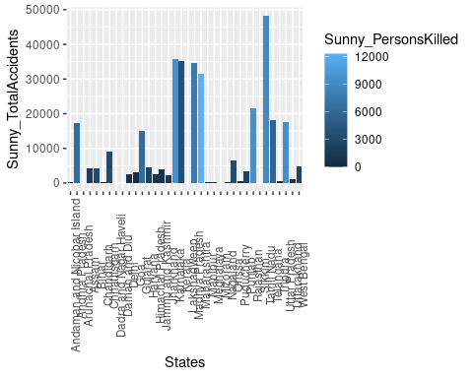

ggplot(data,aes(x=States,y=Rainy_TotalAccidents,fill=Rainy_PersonsKilled)) +  
 geom_bar(stat="identity")+theme(axis.text.x= element_text(angle=90))

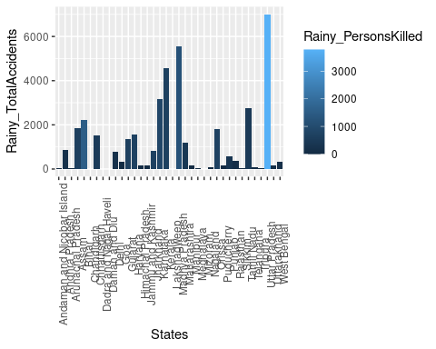

ggplot(data,aes(x=States,y=Sunny_TotalAccidents,fill=Sunny_PersonsGInjured )) +  
 geom_bar(stat="identity")+theme(axis.text.x= element_text(angle=90))

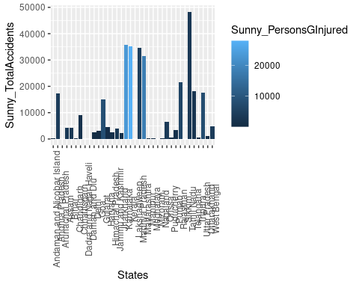

ggplot(data,aes(x=States,y=Sunny_TotalAccidents,fill= Sunny_PersonsMInjured2 )) +  
 geom_bar(stat="identity")+theme(axis.text.x= element_text(angle=90))

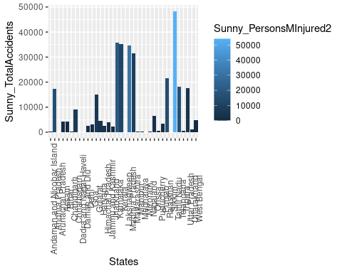

ggplot(data,aes(x=States,y=Rainy_TotalAccidents,fill= Rainy_GreviouslyInjured )) +  
 geom_bar(stat="identity")+theme(axis.text.x= element_text(angle=90))

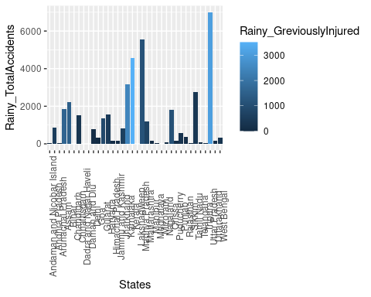

ggplot(data,aes(x=States,y=Rainy_TotalAccidents,fill=Rainy_MinorInjury )) +  
 geom_bar(stat="identity")+theme(axis.text.x= element_text(angle=90))

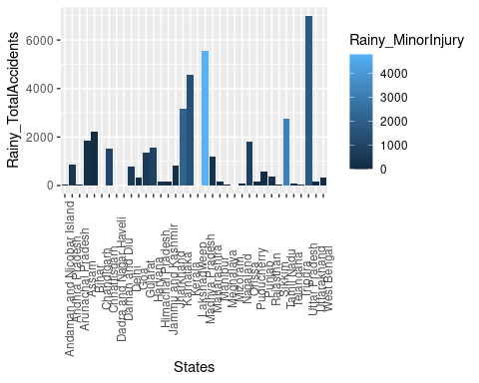

ggplot(data,aes(x=States,y=Foggy_TotalAccidents,fill=Foggy_PersonsKilled)) +  
 geom_bar(stat="identity")+theme(axis.text.x= element_text(angle=90))

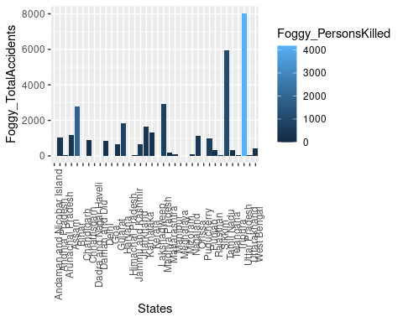

ggplot(data,aes(x=States,y=Foggy_TotalAccidents,fill= Foggy_GreviouslyInjured)) +  
 geom_bar(stat="identity")+theme(axis.text.x= element_text(angle=90))

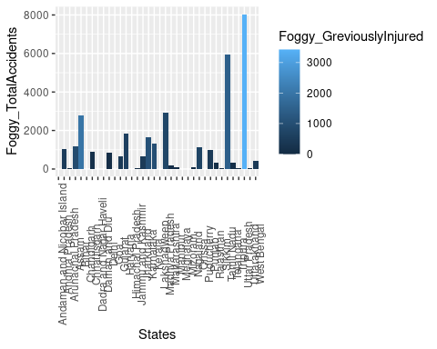

ggplot(data,aes(x=States,y=Foggy_TotalAccidents,fill=Foggy_MinorInjury )) +  
 geom_bar(stat="identity")+theme(axis.text.x= element_text(angle=90))

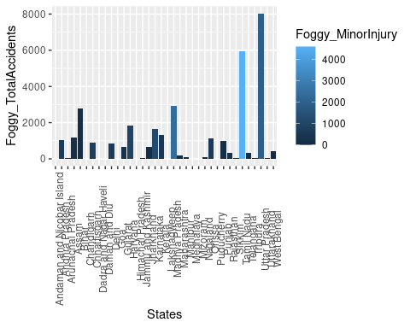

ggplot(data,aes(x=States,y= Sunny_TotalAccidents ,fill=Sunny_TInjured)) +  
 geom_bar(stat="identity")+theme(axis.text.x= element_text(angle=90))

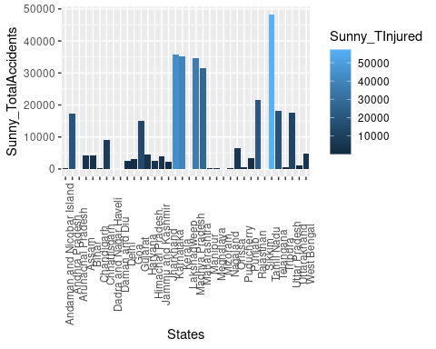

ggplot(data,aes(x=States,y= Rainy_TotalAccidents ,fill= Rainy_TotalInjured)) +  
 geom_bar(stat="identity")+theme(axis.text.x= element_text(angle=90))

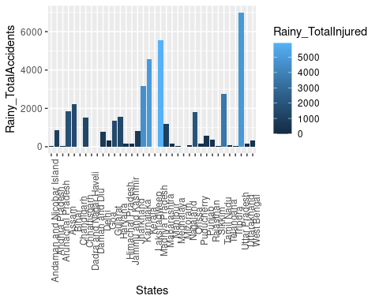

ggplot(data,aes(x=States,y= Foggy_TotalAccidents ,fill= Foggy_TotalInjured )) +  
 geom_bar(stat="identity")+theme(axis.text.x= element_text(angle=90))

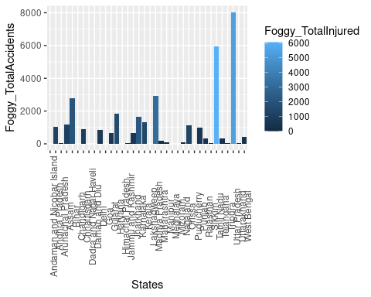

**INFERENCE:**

From the histogram analysis the category of over speeding and sunny , rainy and foggy sides has the maximum number of accidents.

In which the over speeding caused the loss of life to the many persons in more than 7 states

From the bar plot the states like Uttar Pradesh and due to over speeding and weather like rainy and foggy lot of accidents with a grievous injury

The Tripura is the only state which has the maximum number of accidents on traffic accident who are grievously injured and maximum persons are killed in accidents.

The Uttar Pradesh and Puducherry states has crossed their traffic rules by driving their vehicles on wrong sides and crossing the red lights and got killed

Especially the Uttar Pradesh state is used to made accidents by using their mobile phones while driving it shows that the Uttar Pradesh state is not maintaining their rules and regulations properly

By the further visualization we got to know that there is no any relationship in any of the attributes for occurring accidents. But the drunken driving leads to the traffic violation

**INSIGHS:**

The traffic rules and regulation must be wanted to more focus on the states like tamilnadu, Uttar Pradesh and Puducherry

From the analysis, driving the vehicle in high speed leads to the more no of accidents and many of their life’s are got lost.

Tamilnadu is ranking high among all states in making the accident due to driving very fast. As teenagers are get excited to drive high cc bikes without any awareness they are leading to lost their life within a fraction of seconds